**Errors**

**Goodnight error** for:

>go fishing>ready>cast line>goodnight ---- NEVERMIND IT WORKS FOR THIS ONE!

>go swimming>jump>Fiona>willy>goodnight

***note that if you refresh the page it works

This is what happens when I refresh the page

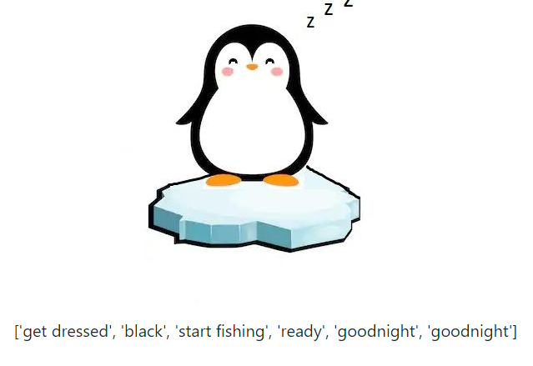

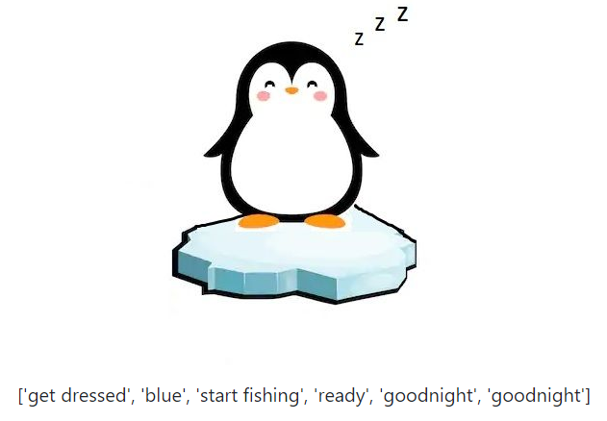

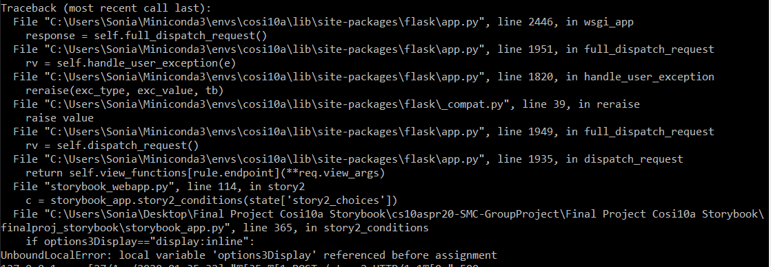

**Shows wrong page because it enter wrong value into list**

Shows make cake page instead of buy cake page for…. >go swimming>jump>willy>buy cake

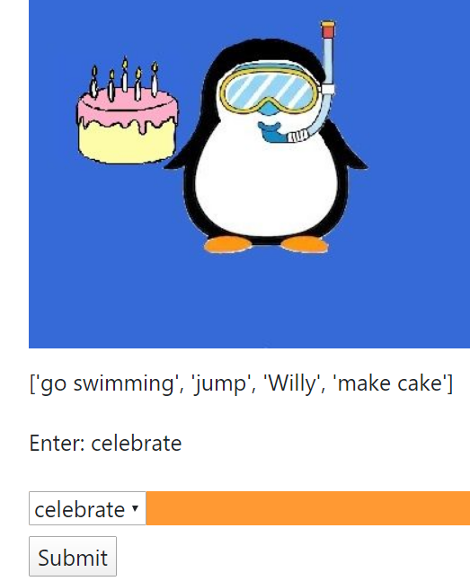

This is what happens when I click buy cake

Shows make willy page instead of colby page for…. Go fishing>ready>go swimming>jump>Colby

Shows fiona_willy page instead of Fiona_colby for… >go swimming>jump>Fiona>Colby